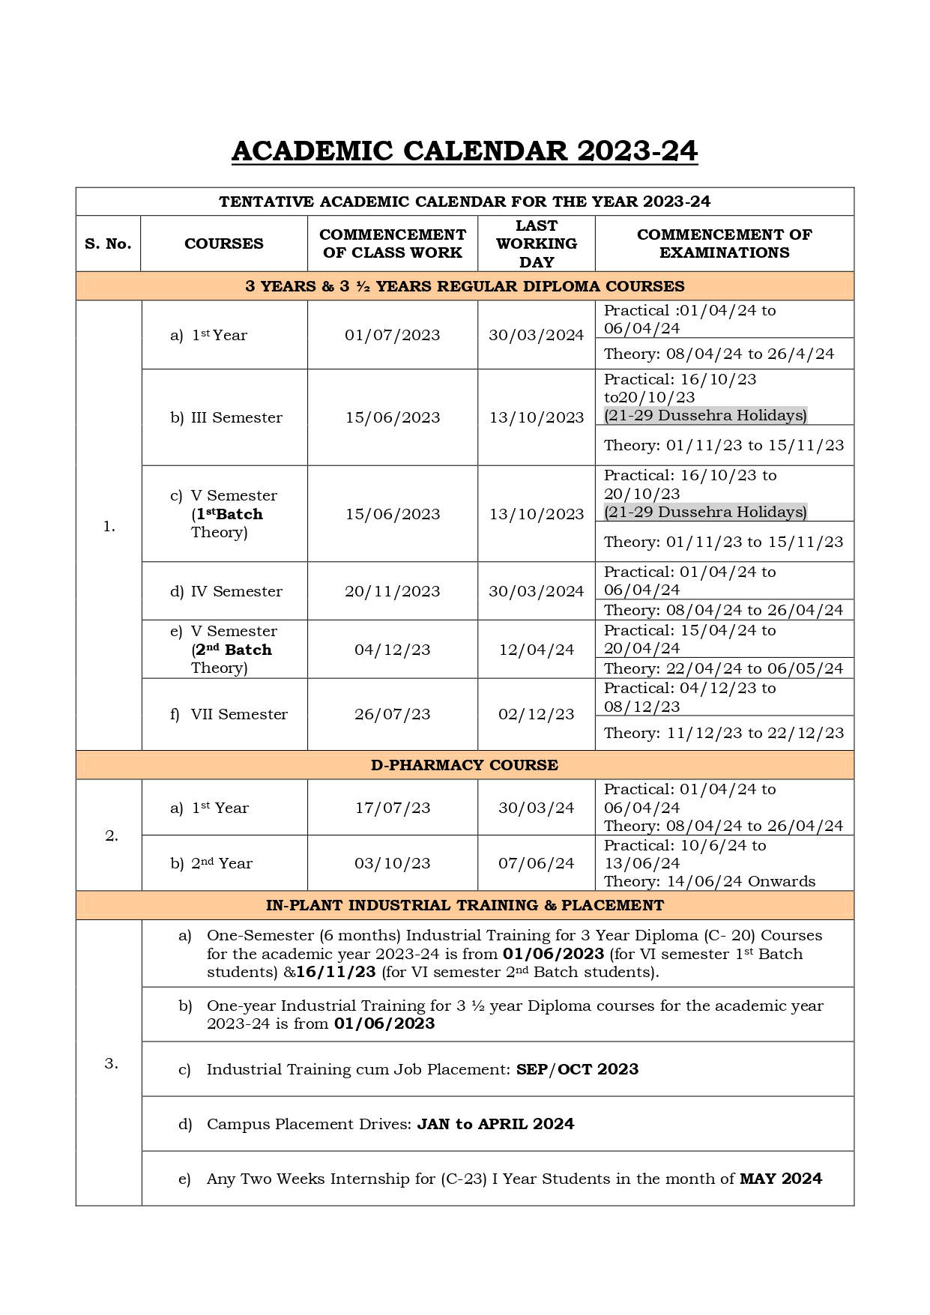

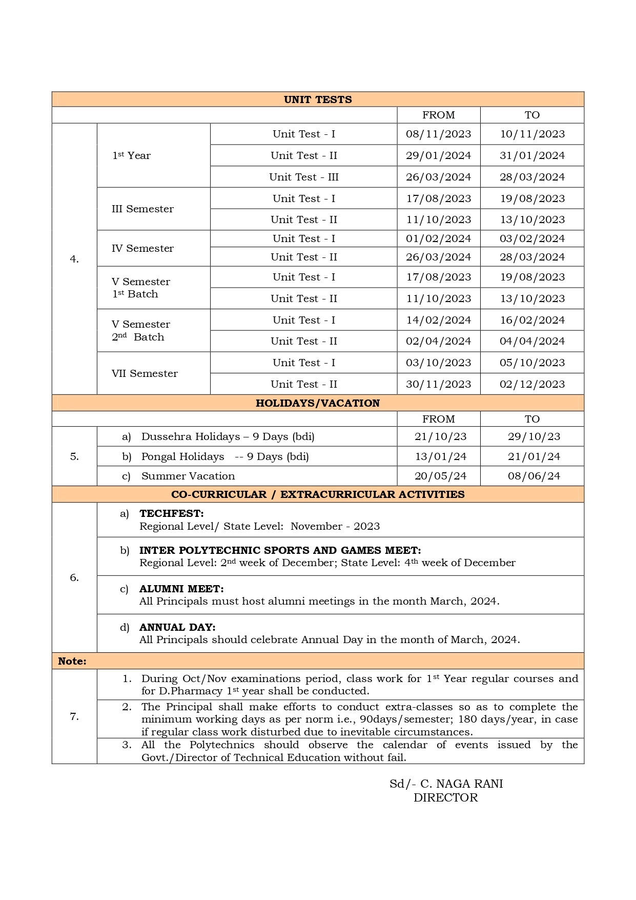

**CAY m1:2022-2023:**

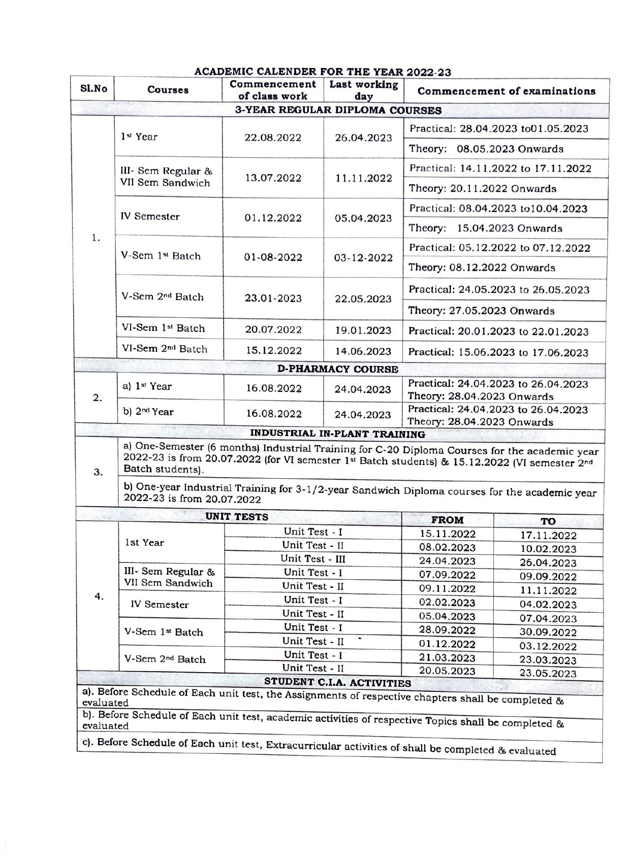  
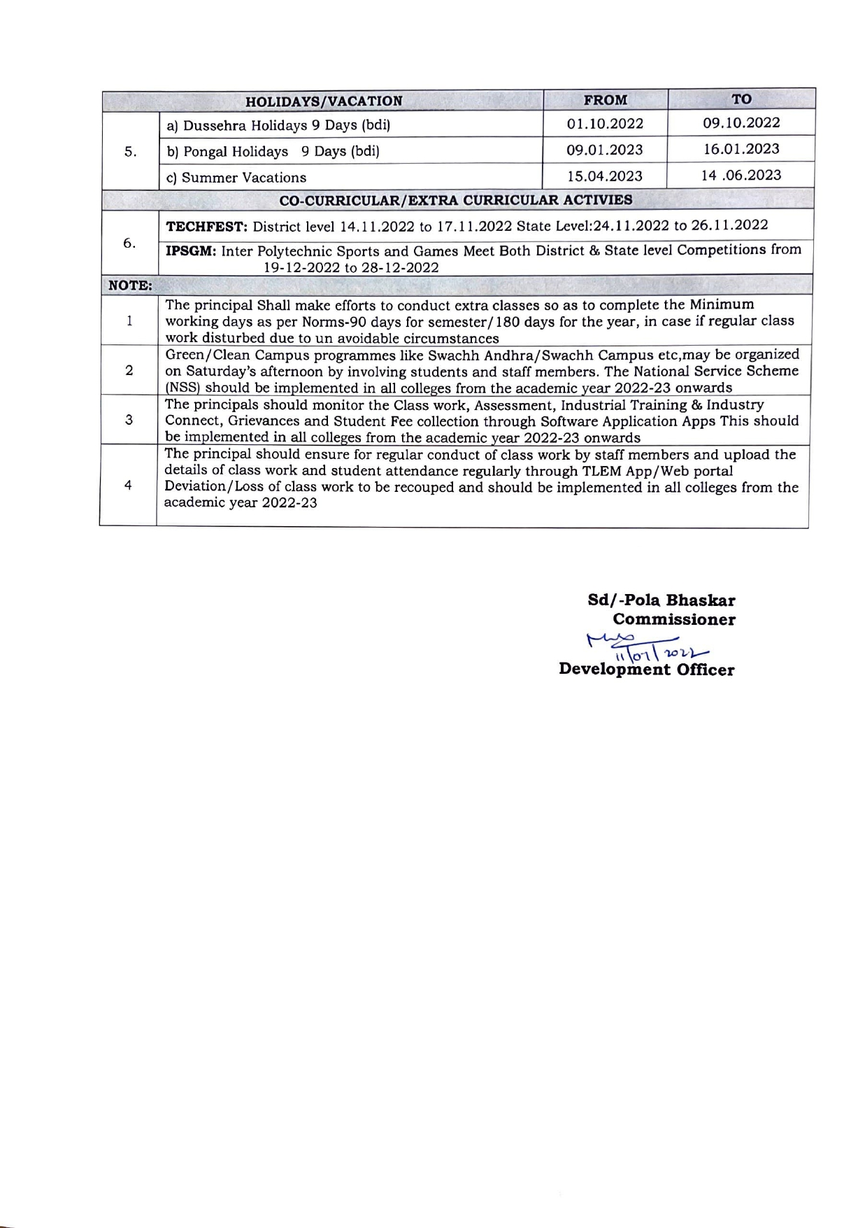

**CAY m2:2021-2022**

|  |  |  |  |  |  |  |  |
| --- | --- | --- | --- | --- | --- | --- | --- |
| ACADEMIC CALENDER FOR THE YEAR 2021-22 | | | | | | | |
| SL. NO | COURSES | | COMMENCEMENT OF CLASS WORK | | LAST WORKING DAY | | |
| 3-YEAR REGULAR DIPLOMA COURSES | | | | | | | |
| 1. | a) 1st Year  for all Branches of Diploma | | 18.10.2021 | | 31.05.2022 | | |
| b) III Regular Diploma | | 07.10.2021 | | 02.02.2022 | | |
| c)IV - Semester | | 11.02.2022 | | 09.06.2022 | | |
| d)V - Semester (1st Batch) | | 20.09.2021 | | 16.01.2022 | | |
| e)V - Semester (2nd Batch ) | | 23.02.2022 | | 22.06.2022 | | |
| f) VI Semester (1st Batch) | | 20.09.2021 | | 19.02.2022 | | |
| g) VI Semester (2nd Batch) | | 22.01.2022 | | 21.06.2022 | | |
|  | h) VII Semester  (for 3 ½ year sandwich Diploma) | | 13.07.2021 | | 12.11.2022 | | |
| PHARMACY COURSE | | | | | | | |
| 2. | a)1st Year D.Pharmacy | | 18.10.2021 | | 31.05.2022 | | |
| b) 2nd Year D.Pharmacy | | 04.10.2021 | | 31.05.2022 | | |
| INDUSTRIAL IN-PLANT TRAINING | | | | | | | |
| 3. | a) One-Semester Industrial Training for C-16 Diploma Courses for the academic year  2021-22 is from 20.09.2021 (for VI semester 1st Batch) & 22.01.2022(for VI semester 2nd Batch). | | | | | | |
| b) One-year Industrial Training for 3-1/2-year Sandwich Diploma courses for the academic year 2021-22 is from 20.09.2021 | | | | | | |
| UNIT TESTS | | | | | | | |
|  | | | | FROM | | | TO |
| 4. | 1st Year | Unit Test – I | | 20.12.2021 | | | 22.12.2021 |
| Unit Test – II | | 07.03.2022 | | | 09.03.2022 |
| Unit Test – III | | 19.05.2022 | | | 21.05.2022 |
| III/V  Semester | Unit Test – I | | 01.12.2021 | | | 03.12.2021 |
| Unit Test – II | | 06.01.2022 | | | 08.01.2022 |
| IV/VI  Semester | Unit Test – I | | 06.04.2022 | | | 08.04.2022 |
| Unit Test – II | | 30.05.2022 | | | 01.06.2022 |
| INTER-POLYTECHNIC SPORTS AND GAMES MEET(IPSGM) – 27.12.2021 TO 07.01.2022 | | | | | | | |
| TECH FEST – 2021,  DISTRICT LEVEL: 15.11.2021 TO 22.11.2021 :: STATE LEVEL: 25.11.2021 TO 28.11.2021 | | | | | | | |
| HOLIDAYS/VACATION | | | | | | | |
|  | | | | FROM | | TO | |
| 5. | a) Dassera Holidays - | | | 13.10.2021 | | 15.10.2021 (bdi) | |
| b) Pongal Holidays - | | | 13.01.2022 | | 16.01.2022 (bdi) | |
| NOTE: | | | | | | | |
| 1 | During Semester examinations period, class work for 1st Year regular courses and  D. Pharmacy 1st year shall be conducted. | | | | | | |
| 2 | The Principal shall make efforts to conduct extra-classes so as to complete the minimum working days norm: 90days/semester; 180 days/year, in case if the regular class work  disturbed due to unavoidable circumstances (strikes/natural calamities etc). | | | | | | |
| 3 | Consent from the parent of the student to attend the institution shall be taken. | | | | | | |
| 4 | Undertaking by the students to abide the COVID-19 guidelines shall be taken. | | | | | | |

**CAY m3:2020-2021**

